EtherChannel
CCNA study notes · Link aggregation

1. What is EtherChannel?
- EtherChannel groups multiple physical interfaces into one group that operates as a single logical interface.
- Topics in this note: what EtherChannel is, the problem it solves, load balancing, the ways to form one, and Layer 2 vs Layer 3 EtherChannel.

Type | Description
Layer 2 EtherChannel | A group of switch ports that operate as a single interface.
Layer 3 EtherChannel | A group of routed ports that operate as a single interface. You assign an IP address to it because it is Layer 3.

Access vs distribution switch
- An access switch connects end devices (PCs, phones, printers, access points) to the network.
- A distribution switch connects multiple access switches and manages the traffic between them.

Key rule
Access = connects devices. Distribution = connects access switches.

2. The problem EtherChannel solves
In the demonstration there is an access switch (ASW1) and a distribution switch (DSW1). ASW1 has 40 hosts, all trying to reach the internet.
- The network admin notices the connection to DSW1 is congested, so he adds another link to increase bandwidth.
- Even after adding a link, the total bandwidth of the connections to the end hosts is still greater than the bandwidth of the connections to DSW1.
- Hosts are not always sending or receiving traffic at the same time, so this is usually tolerable.
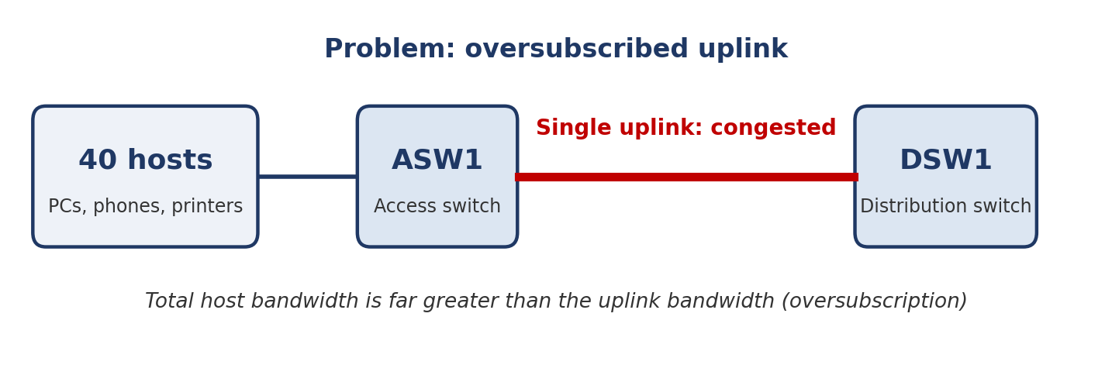
Figure 1: a single uplink shared by 40 hosts
Oversubscription
When the bandwidth of the interfaces connected to end hosts is greater than the bandwidth of the connections to the distribution switch, this is called oversubscription.
Some oversubscription is acceptable, but too much causes congestion. So the admin adds yet another link between the two switches.

3. How EtherChannel works
- The links between ASW1 and DSW1 are grouped into an EtherChannel.
- In network diagrams, an EtherChannel is drawn as a circle around the interfaces.
- The group acts as a single interface, and STP treats it as a single interface.
- All the links show green (forwarding), unlike ordinary parallel links where STP blocks some to prevent loops.
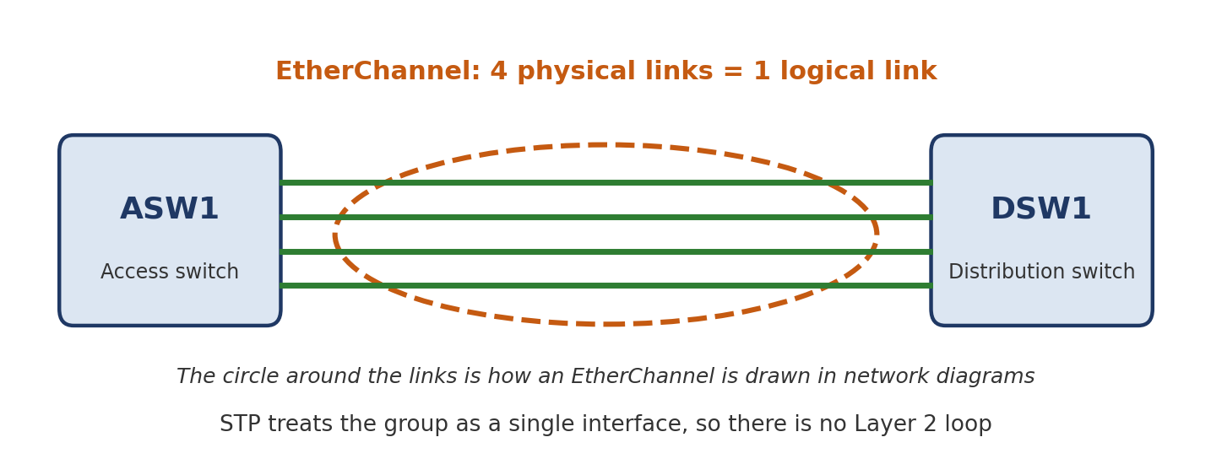
Figure 2: four physical links grouped into one logical link

Does it cause a Layer 2 loop?
No. The four links behave as one link.
- A PC sends a broadcast frame. ASW1 floods it out of every interface except the one it came from, including toward DSW1.
- DSW1 receives a single copy of the frame, because the four physical interfaces act as one logical interface.
- ASW1 does not send a copy out of every member interface. If it did, there would be a broadcast storm and a Layer 2 loop.

Why doesn't DSW1 send the frame back to ASW1 on the other member links?
DSW1 floods the frame out of all interfaces except the one it came in on. The four physical interfaces count as one interface, so none of the other member links is used.

4. EtherChannel load balancing
- Traffic using the EtherChannel is load balanced across the physical interfaces in the group.
- An algorithm decides which physical interface each piece of traffic uses.
- Load balancing is based on flows. A flow is a communication between two nodes on the network.

Example
- PC1 starts exchanging data with Server1. ASW1 receives the frames and, assuming it knows Server1's MAC address, forwards them out of the port channel toward DSW1.
- ASW1 calculates which physical interface to use. Every following frame in that flow uses the same interface.
- If PC2 wants to print, its first frame starts a new flow. ASW1 does a new calculation, which may pick a different member interface.
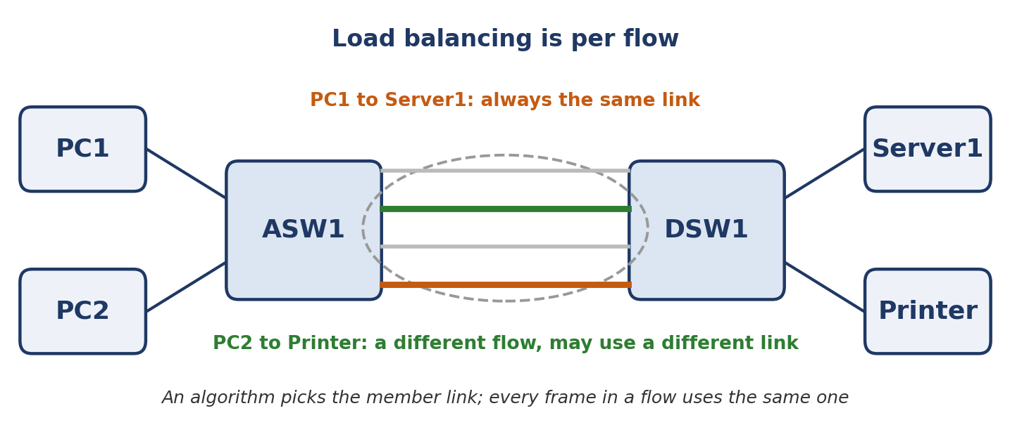
Figure 3: each flow is pinned to one member link
Key rule
Frames in the same flow are forwarded using the same physical interface.
If frames in one flow used different interfaces, some could arrive at the destination out of order, which can cause problems.

Inputs used by the algorithm
The calculation takes a few inputs into account. You can change which input is used:
- Source MAC
- Destination MAC
- Source and destination MAC
- Source IP and destination IP

5. Ways to form an EtherChannel
There are three methods on Cisco switches.
Method | Standard? | Notes
PAgP | Cisco only | Port Aggregation Protocol. Dynamically negotiates the creation and maintenance of EtherChannels, like DTP does for trunks. Frames are sent to the neighbouring switch to see if it wants to form an EtherChannel, and the switches agree to form one or not.
LACP | Industry standard (IEEE) | Link Aggregation Control Protocol. Does the same job as PAgP, negotiating and maintaining EtherChannels dynamically. It is not limited to Cisco switches, so it works across vendors. Preferred method, and the one in the CCNA.
Static | No protocol | Interfaces are manually configured to form the EtherChannel. Usually avoided, because you want the switches to maintain the EtherChannel dynamically.

Why dynamic is better than static
With a protocol, the switch can remove an interface from the EtherChannel automatically if there is a problem on that interface.

6. How many interfaces?
- Up to 8 interfaces can be formed into a single EtherChannel.
- LACP allows up to 16 interfaces, but only 8 are active. The other 8 stay in standby, waiting to replace an active interface that fails.

7. Member interface requirements
The physical interfaces in an EtherChannel must have matching configurations. They must have the same:
- Duplex setting (full or half)
- Speed
- Switchport mode (access or trunk)
- If trunk: the same allowed VLANs and the same native VLAN

Key rule
If an interface's configuration does not match the others, it is excluded from the EtherChannel.

8. Layer 3 EtherChannel
- Modern network design often leans toward Layer 3 connections between switches, because then spanning tree is not an issue.
- For example, four switches can be interconnected in a mesh using Layer 3 routed ports. All interfaces are up and forwarding, and none has to be disabled by spanning tree.
- A Layer 3 EtherChannel combines routed ports into one interface that you give an IP address.

9. Still to cover
- Configuring Layer 2 EtherChannel
- Configuring Layer 3 EtherChannel

